ECE282 Lab 3

Austin Sypolt

1. Command Practice and warmups
2. Who

Displays a list of online users

1. Whoami

Displays user id (asypolt for me)

1. Cp

Copies a file’s contents to another (cp –source file- -source destination). If the file already exists it will override it, if it doesn’t it will create a new file.

1. Rm

Rm –file-, allows for the removal of files or directories.

1. Open()

Opens and possibly creates a file, it is a linux system call

1. Read()

Reads a given number of bytes from a file, it is a linux system call

1. Fgets()

Reads in characters from stream and stores them into them in the given pointed to buffer

1. Fputs()

Writes the string pointed to by str to the stream pointed to by stream

1. Lseek()

Used to change the location of the read/write pointer of a file descriptor

1. Perror()

Prints an error message to stderr

1. Getchar() vs getch()

Getchar() retrieves a byte from a stdin stream

Getch() reads a single character from an input device without echoing

* Search man pages for the following key words

1. Who

Man –k who

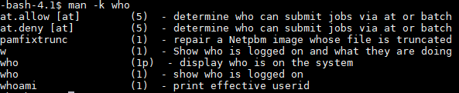

1. Whoami

Man –k whoami



1. Cp

Man –k cp



1. Rm

Man –k rm

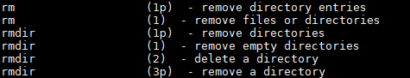

1. Exercise to be submitted
2. Write append program. This program must be able to accept two arguments which are as destination and source files. Then, the content of the source file must be appended to the destination file. The program must also accept --help argument, in which case, would show some help instructions regarding its functionalities and synopsis.

In case destination file does not exist, it must be created. In case source file does not exist, the program should indicate and print an error message accordingly and exit. In case no argument is given, the program should indicate the error.

The order of arguments to be fed into the program is as follows:

./append destination source

./append –help

You can use the source codes that are available on Canvas.

Upload the source code (.c file) of your program to the Canvas.

**Note:** Source file name must be one file, named append.c

**Note:** The program must be compiled with no error.